Name: Date: ea words 2

The long (e) sound is often represented by the letters ea when it comes in the middle of words, like in the words below.

Remember: Say the word aloud, then say each letter aloud as you write it e.g. 'meal, m ... e ... a ... l'

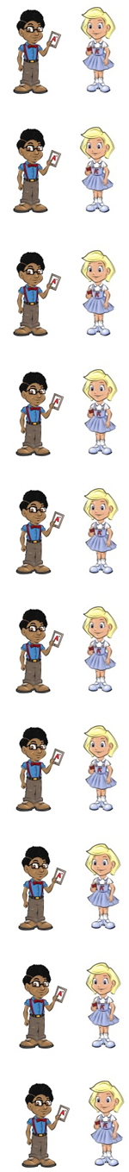
A meal is something that you eat.

Ghosts are not real.

If you steal something you take it without paying.

In some sports you play in a team.

A dream is something you really want to do.

A stream is a small river.

A scream is very loud.

A bean is a small vegetable.

If you are mean, you are not nice.

Neil will never clean his room.

Now test yourself without looking at the words and check for yourself if you got them all right. Practice writing any words that you made mistakes on again.

© www.SaveTeachersSundays.com 2013
Name: Date: ea words 2

The long (e) sound is often represented by the letters ea when it comes in the middle of words, like in the words below.

Remember: Say the word aloud, then say each letter aloud as you write it e.g. 'meal, m ... e ... a ... l'

Try to spell each word without looking at it.

A is something that you eat.

Ghosts are not .

If you something you take it without paying.

In some sports you play in a .

A is something you really want to do.

A is a small river.

A is very loud.

A is a small vegetable.

If you are , you are not nice.

Neil will never his room.

Now check for yourself if you got them all right. Practice writing any words that you made mistakes on again.

© www.SaveTeachersSundays.com 2013

